## Ex.No: 1 PROBLEM STATEMENT – STOCK MAINTENANCE SYSTEM

**Aim:**

To write a problem statement for stock maintenance system.

## Problem statement:

* The stock maintenance system which take care of sales information of the company and analyze the potential of the trade. It maintains the data in efficient manner. The existing system was recorded manually on pen and paper and time consuming one. To overcome this we are operating it in system and database for delivering accurate and real time information on stocks. This is also helps in calculating the total stocks, pending stocks and updating. It is mainly used in business sector to maintain stock level and profit and unprofitable product. This is mainly used by sales person and customers. This system is used for time and money saving, increases productivity and efficiency and also used for accurate data analysis of stocks. Also used for analysis the data in real-time requirements of the stocks.

## Result:

Thus the problem statement for stock maintenance system was written successfully.

## Ex.No:2 Software Requirement Specification –

## stock maintenance system

## Aim:

To study and write the software requirement specification for stock maintenance system.

## Introduction:

Stock maintenance is an interface between the customer and the sales person. It aims at improving the efficiency in maintaining the stocks

## Scope:

* The system provides an interface to the customer where they can fill in orders for the items needed.
* The sales person is concerned with the issues of items and can use this system.
* Provide a communication platform between the customer and the sales person.

## Requirements:

**Functional Requirements:**

Stock maintenance system involves the following functions:

**CUSTOMER REGISTRATION:**

* + SMS provides customer registration and status information to the administration to view their status.
  + Stock maintenance system provides automatic customer register number generated based on randomization algorithm.
  + Stock maintenance system provides to customer to purchase product and enlist them in the profile.

**PRODUCT MANAGEMENT :**

* Easily track product information.
* Quickly iproduce reports for single or multiple sold products.

## Non functional requirements:

The following are the required that focus on the overall quality of the software.

## Usability:

The product should be simple enough to be operated by the actors concerned.

## Efficiency:

The product should occupy the least possible memory space and provide greater performance.

## Reliability:

The database must not be corrupted in case of power failure or any malfunctioning of the underlying

system.

**Deliverability:**

The deliverable product must include the database pack necessary to handle the software along with the software itself.

## Implementation:

The product should be safe to use and should not be easily subjected to hacking.

## Hardware Requirement:

* PROCESSOR: 64 BIT
* ROM: 2GB
* RAM:4GB

## Software Requirement:

* OPERATING SYSTEM: WINDOWS 8/10
* FRONT END: JAVA NETBEANS
* BACK END: MYSQL

## Result:

Thus the software Requirement specification for the stock maintenance system was written successfully.

## Ex.No:3 Use case diagram – Stock maintenance sytsem

**Aim:**

To draw a usecase diagram to implement stock maintenance system.

## Description:

In UML, use case diagrams model the behavior of a system and help to capture the requirements of the system. It gives a graphic overview of the actors involved in a system, different functions needed by these actors and how these different functions interact.

## Use case diagram for stock maintenance system:

The use cases used in this system are

1. **Product details:**

Used for placing an order.

1. **Purchase details:**

Used for tracking items that have been ordered.

1. **Sale details:**

Used for give the sales particulars about a items.

1. **Stock details:**

Used for give the stock details in a shop.

1. **Purchase the product:**

Used to provide bills for the customers.

1. **Supply the product:**

Used to give the order product to customer.

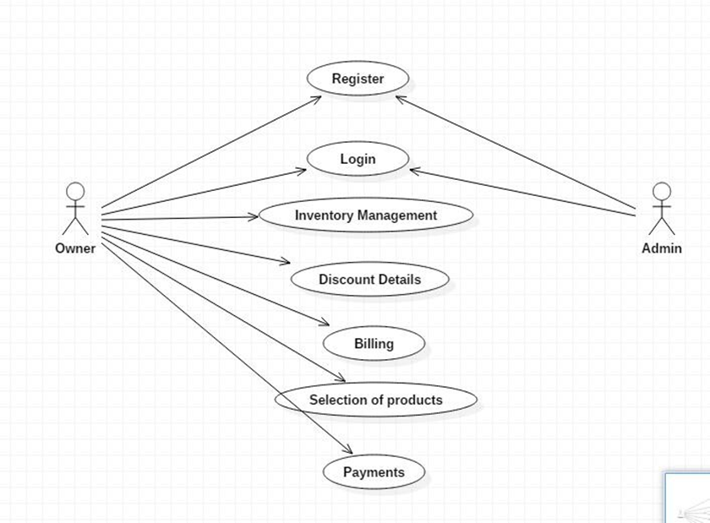

## Result:

Thus the use case diagram for stock maintenance system was drawn successfully.

## Ex.No:4 Class diagram – stock maintenance system

**Aim:**

To draw a class diagram for stock maintenance system

## Description:

Class diagrams are the main building blocks in object oriented modeling. They are used to show the different objects in a system, their attributes, their operations and the relationship among them. They are the blueprints of the system.

## Class diagram for stock maintenance system:

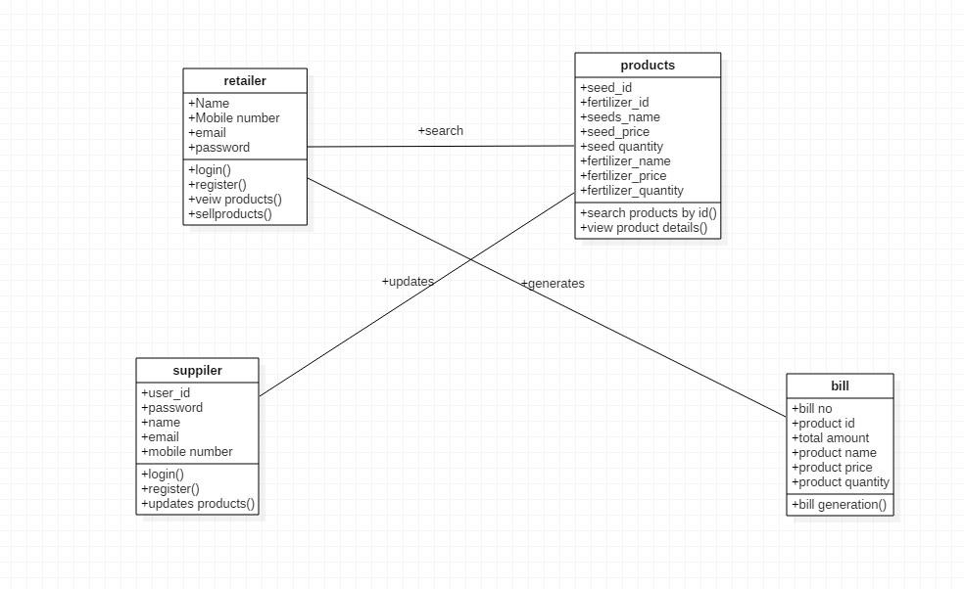

**RETAILER:**

* + - The person who handles with the product for purchasing and processing to further process.
    - He can entire using login and register details.

**SUPPLIER:**

* + - The person who deals with restock the goods
    - The person will send notification to admin to add and modify the stocks.

**ADMIN:**

* + The person who adds and modify the goods present in the page.
  + Then process the message to suppliers for sending the stocks

## Result:

Thus the class diagram for stock maintenance system was drawn successfully.

## Ex.No:5 Sequence and Collaboration Diagram –

## Stock maintenance system

## Aim:

System.

To study and draw the sequence diagram and collaboration diagram for stock maintenance

## Sequence Diagram:

A sequence diagram simply depicts interaction between objects in a sequential order i.e. the order in which these interactions take place. We can also use the terms event diagrams or event scenarios to refer to a sequence diagram. Sequence diagrams describe how and in what order the objects in a system function. These diagrams are widely used by businessmen and software developers to document and understand requirements for new and existing systems.

## Sequence diagram for Stock maintenance system:

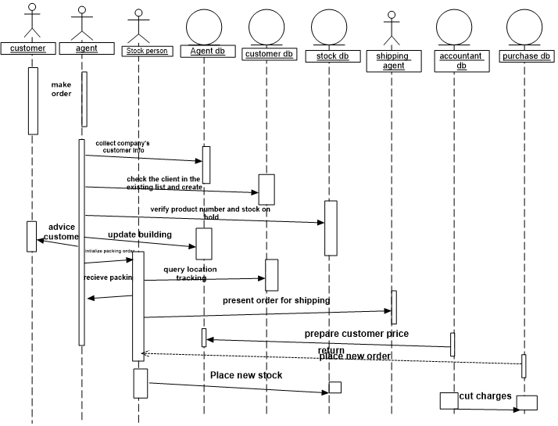

## Collaboration Diagram:

The collaboration diagram is used to show the relationship between the objects in a system.

Multiple objects present in the system are connected to each other. The collaboration diagram, which is also known as a communication diagram, is used to portray the object’s architecture in the system.

## Collaboration diagram for Stock Maintenance system:

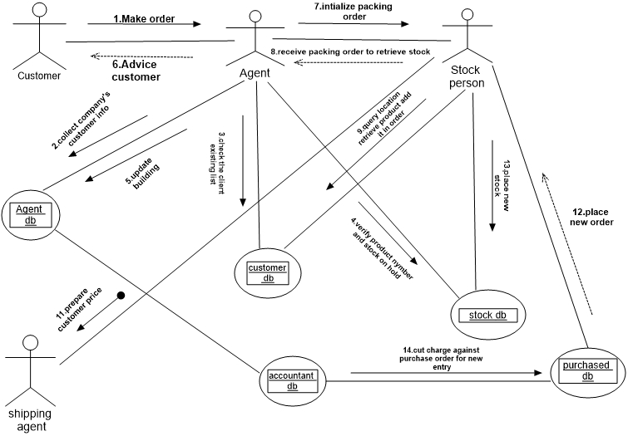

## Result:

successfully.

Thus the sequence diagram and collaboration diagram for Stock maintenance system were drawn

## Ex.No:6 State chart and activity diagram –

## stock maintenance system

## Aim:

To study and draw the state chart and activity diagram for the stock maintenance system.

## State chart diagram:

A state chart diagram is used to represent the condition of the system or part of the system at finite instances of time. It’s a behavioral diagram and it represents the behavior using finite state transitions. State diagrams are also referred to as **State machines** and **State-chart Diagrams.** These terms are often used interchangeably. So simply, a state diagram is used to model the dynamic behavior of a class in response to time and changing external stimuli.

**State chart diagram for stock maintenance system:**

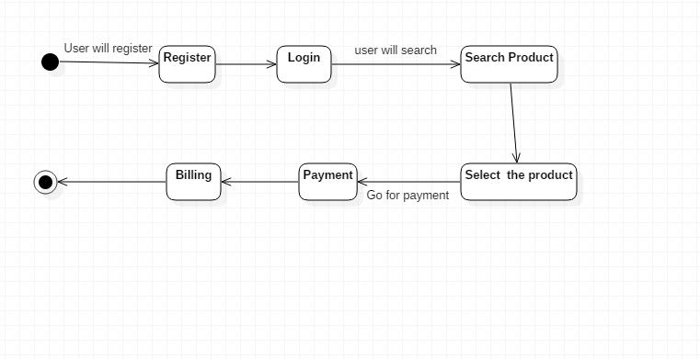

## Activity diagram:

We use Activity Diagrams to illustrate the flow of control in a system. We can also use an activity diagram to refer to the steps involved in the execution of a use case. We model sequential and concurrent activities using activity diagrams. So, we basically depict workflows visually using an activity diagram. An activity diagram focuses on condition of flow and the sequence in which it happens. We describe or depict what causes a particular event using an activity diagram.

**Activity diagram for stock maintenance system:**

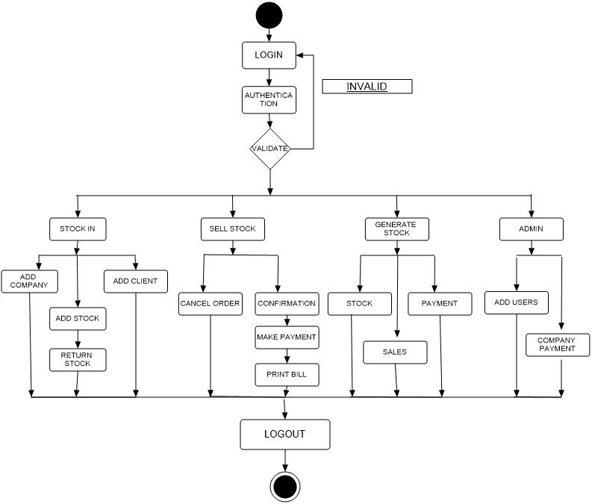

## Result:

Thus the state chart and activity diagram for the stock maintenance system was drawn successfully.

## Ex.No: 7 User-Interface Layer

**Aim:**

To design a user interface layer, where the system interact with the user using various forms.

## Form 1:

A admin will enter the page using the correct username and password for add, modify and deleting of stocks.

## Form 2:

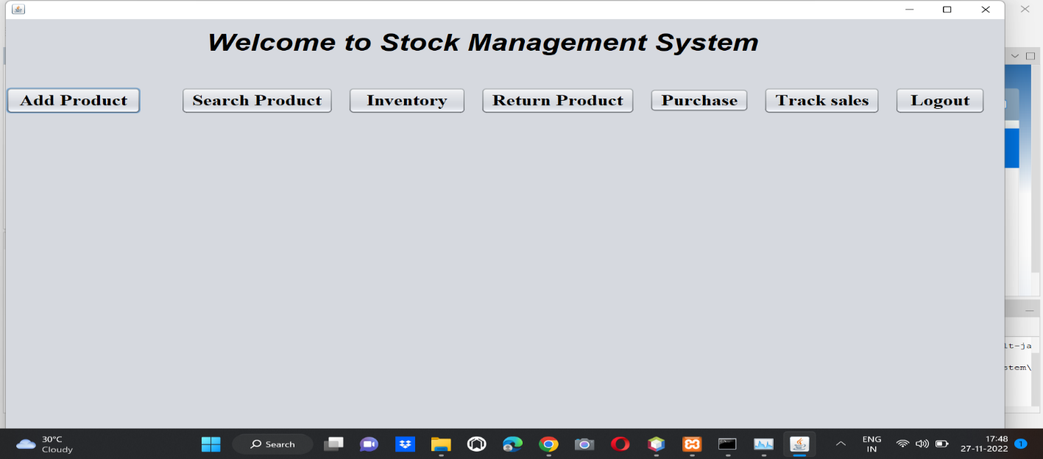

## Form 3:

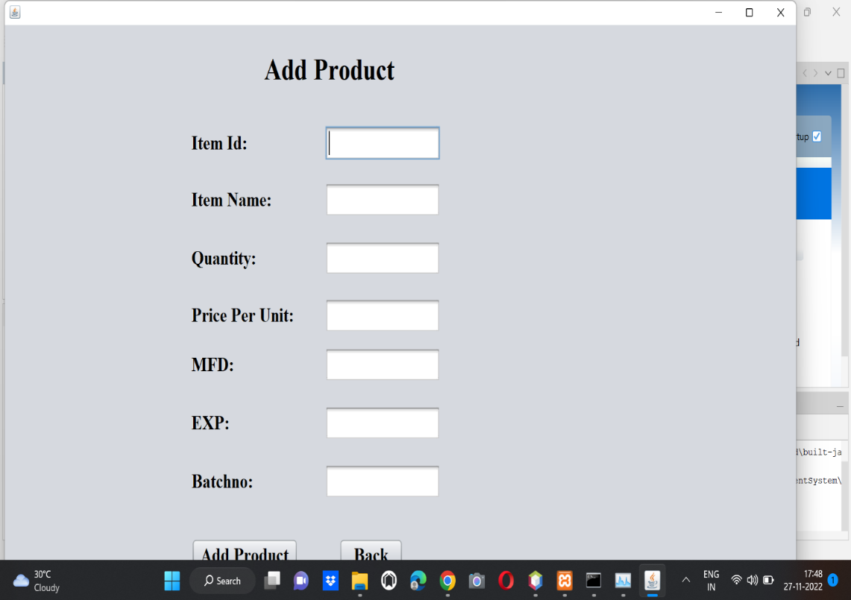

## Form 4:

## Form 5:

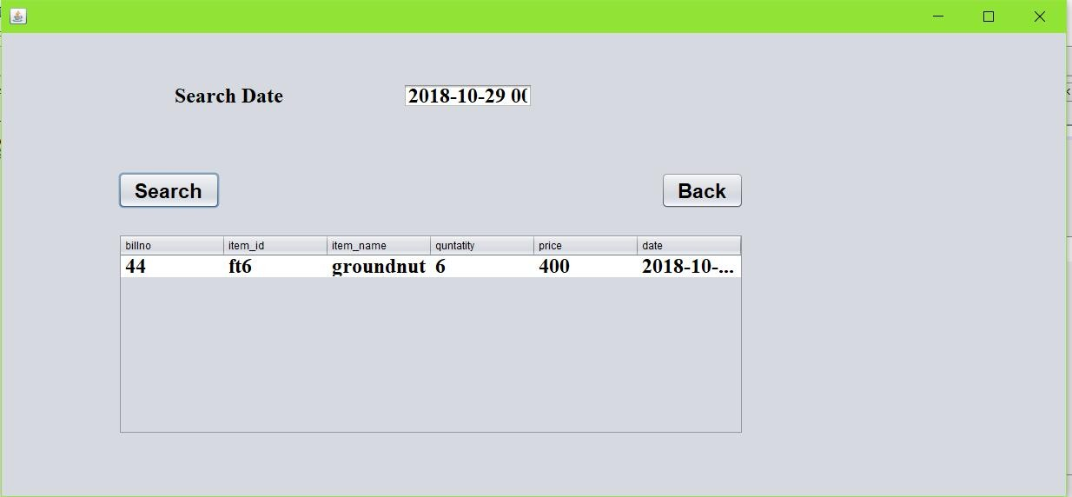

## Result:

Thus the user interface layer, where the system interact with user using various forms for the stock

Maintenance system was designed successfully.

## Ex.No: 8 Database Layer

**Aim:**

To implement a database for the designed forms of the stock maintenance system.

**Stock database:**

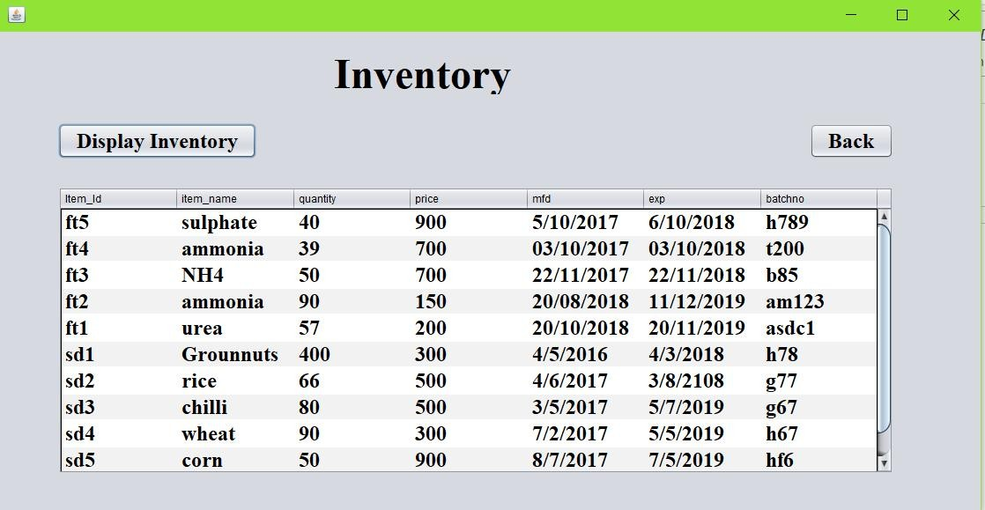

**Results:**

**T**hus the database layer was implemented successfully for the stock maintenance system

.